Southern District Council South Horizons West Constituency

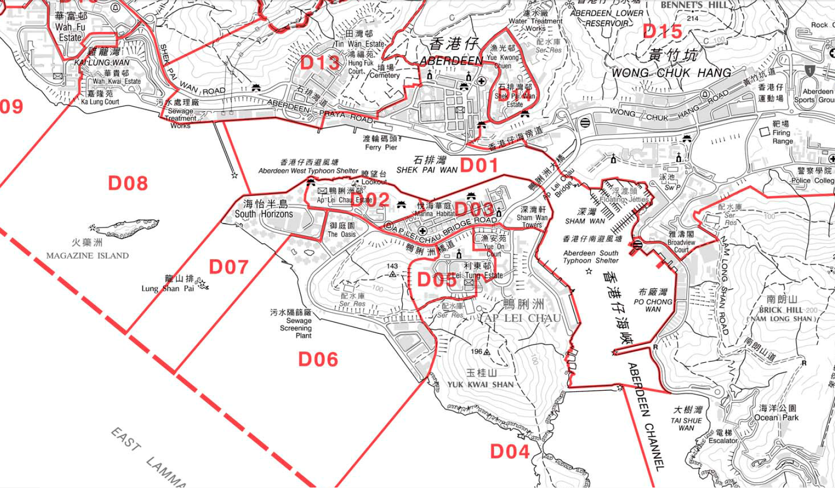

D07 is the Southern District South Horizons West Constituency.
generated from the document of the Electoral Affairs Commission

